Visual Analysis

Definition
# Source: AI Source: Provided by: [Data Path: Persons Table -> ID Column: 1, Name_En Column: Motasem Essam] -> From: [Chatgpt (GPT‑5 Mini)] on [12/10/2025]
Visual analysis is the process of interpreting data using graphical representations such as charts, graphs, dashboards, and plots.
- Makes complex data easier to understand and analyze.
- Helps identify patterns, trends, outliers, and relationships quickly.

Key idea:
# Source: AI Source: Provided by: [Data Path: Persons Table -> ID Column: 1, Name_En Column: Motasem Essam] -> From: [Chatgpt (GPT‑5 Mini)] on [12/10/2025]
It’s like turning numbers into pictures so that insights are instantly visible without reading all the raw data.

Characteristics of Visual Analysis
# Source: AI Source: Provided by: [Data Path: Persons Table -> ID Column: 1, Name_En Column: Motasem Essam] -> From: [Chatgpt (GPT‑5 Mini)] on [12/10/2025]
- Uses charts, graphs, dashboards, and interactive visualizations
- Can handle both quantitative and qualitative data
- Often combined with statistical or exploratory analysis
- Helps with decision-making, reporting, and presentations
- Can be done using tools like Excel, Tableau, Power BI, Python (Matplotlib, Seaborn)

Examples
# Source: AI Source: Provided by: [Data Path: Persons Table -> ID Column: 1, Name_En Column: Motasem Essam] -> From: [Chatgpt (GPT‑5 Mini)] on [12/10/2025]
- Bar Chart: Compare monthly sales across different regions.
- Line Chart: Show trends of stock prices over time.
- Pie Chart: Display market share of different products.
- Heatmap: Visualize correlation between multiple variables.
- Dashboards: Combine multiple visualizations for a complete overview of KPIs.

Advantages
# Source: AI Source: Provided by: [Data Path: Persons Table -> ID Column: 1, Name_En Column: Motasem Essam] -> From: [Chatgpt (GPT‑5 Mini)] on [12/10/2025]
- Makes data easier to understand and interpret
- Highlights trends, patterns, and anomalies quickly
- Supports faster decision-making
- Improves communication of insights to non-technical users
- Can handle large datasets visually without examining raw numbers

Disadvantages
# Source: AI Source: Provided by: [Data Path: Persons Table -> ID Column: 1, Name_En Column: Motasem Essam] -> From: [Chatgpt (GPT‑5 Mini)] on [12/10/2025]
- Can be misleading if visualized incorrectly (e.g., wrong scale or chart type)
- May oversimplify complex data, hiding important details
- Requires software tools and technical skills for advanced visualizations
- Not all insights can be captured visually; some require numerical analysis
- Can be time-consuming to prepare interactive or detailed dashboards

Example Section
# Source: AI Source: Provided by: [Data Path: Persons Table -> ID Column: 1, Name_En Column: Motasem Essam] -> From: [Chatgpt (GPT‑5 Mini)] on [12/10/2025]
A school wants to compare average scores of Class 10A and 10B across subjects:
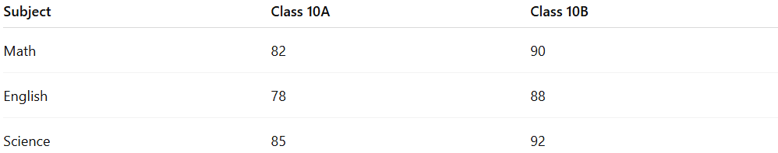
Subject | Class 10A | Class 10B
Math | 82 | 90
English | 78 | 88
Science | 85 | 92
Visual Analysis:
- Bar chart shows Class 10B outperforming 10A in all subjects
- Line chart shows trend of improvement across subjects
- Teacher quickly identifies areas where 10A needs additional support
Outcome:
- Visual representation makes it easy to interpret data and make decisions for remedial classes.

